ASTROSAGE

Analysis by Juned Shaikh

**Objective Questions**:

1. **What is the total no. of tables present in the data?**

* The Data Set Consist of data about the Astrosage’s Services provided and it contains one table with the raw data named “Raw Data Sheet”

1. **What is the total no. of attributes present in the data?**

* The Total no. of attributes present in the data set is 35 and are listed below with description.

1. **_id:** Unique identifier for each record.
2. **user:** User ID associated with the record.
3. **chatStatus:** Status of the chat (e.g., incomplete, failed, completed).
4. **guru:** Unique identifier for the guru.
5. **guruName:** Name of the guru.
6. **gid:** Guru ID.
7. **uid:** User ID.
8. **consultation Type:** Type of consultation (e.g., Chat, Call).
9. **website:** Source of the consultation (e.g., gurucool).
10. **Refund Status:** Indicates if the session is refundable or not (e.g., no-refund).
11. **is WhiteList User:** Boolean indicating if the user is whitelisted.
12. **chat Seconds:** Duration of the chat in seconds.
13. **queue:** Boolean indicating if the session was queued.
14. **FreeCall:** Boolean indicating if the call was free.
15. **Free Chat:** Boolean indicating if the chat was free.
16. **CreatedAT:** Original creation date and time.
17. **updatedAt:** Original update date and time.
18. **__v:** Version key.
19. **statementEntryId:** Identifier for the statement entry.
20. **chatStartTime:** Start time of the chat.
21. **chatEndTime:** End time of the chat.
22. **timeDuration:** Undefined, some technical data as per app. (Don’t use it as the duration of chat/call)
23. **callChannel:** Channel used for the call.
24. **calIvrType:** IVR type used during the call.
25. **callStatus:** Status of the call.
26. **CallSid:** Unique identifier for the call session.
27. **amount:** Amount charged for the session.
28. **astrologerCallStatus:** Status of the astrologer during the call.
29. **astrologerOnCallDuration:** Duration of the astrologer's call.
30. **astrologersEarnings:** Earnings of the astrologer from the session.
31. **netAmount:** Net amount after deductions.
32. **region:** Region of the user.
33. **userCallStatus:** Status of the user's call.
34. **userOnCallDuration:** Duration of the user's call.
35. **rating:** Rating assigned based on the session's status.
36. **The data consists of some inconsistent and missing values so ensure that the data used for further analysis is cleaned.**

* Blank Chatstatus :- if free call = True then enter not applicable and If false then enter failed
* Blank ChatSeconds :- was replaced with 0.
* Blank Time Duration:- was replaced with 0.
* Blank Amount :- was replaced with 0
* Blank astrologersEarnings - was replaced with 0
* Blank netAmount - was replaced with 0

1. **What is the change in daily call volume day by day and also find the average of daily call volume?**

* The Daily Call volume is decreasing day by day and more user are going with chat option as it is more covenants for the user and average of daily call volume is **254.576** (excel G36)Created 3 more Columns with title **Date, Month Year, Year** to analysis the data and created a new sheet for pivot table **Daily Call Volume Pivot** in sheet **Daily Call Volume.**

Formula Used:-

Formula Used is **=AVERAGE(B4:B37)**

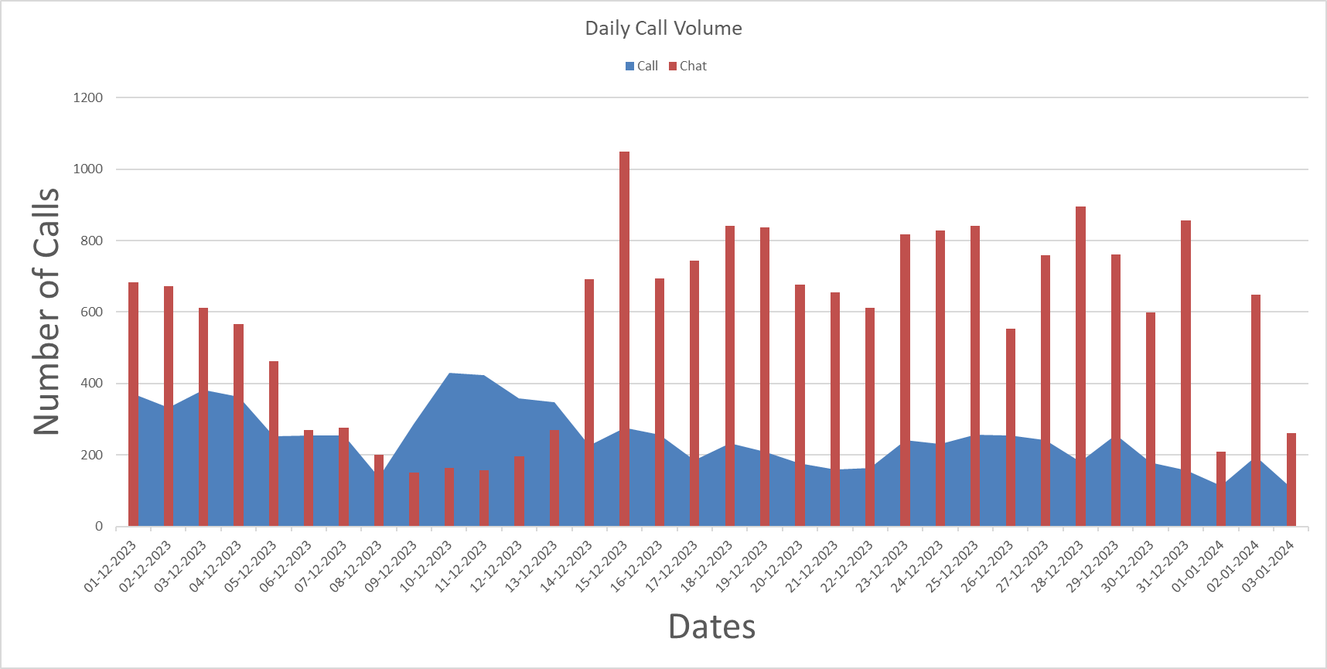

1. **Which months experienced the highest and lowest call volumes?**

* The Month of December Experience the highest and Month of Jan Experience the lowest call volume.

|  |  |
| --- | --- |
| **Count of _id** | **Column Labels** |
| **Row Labels** | **Call** |
| Jan | 418 |
| Dec | 8090 |

1. **What is the total operational cost for that month?**

* Only Operational cost we have is **astrologersEarnings** so created a new column Operational Cost with the values of **astrologersEarnings.**

|  |  |
| --- | --- |
| **Row Labels** | **Sum of Operational Cost** |
| Jan-24 | 5360.408 |
| Dec-23 | 93786.16295 |
| **Grand Total** | **99146.57095** |

1. **What is the average number of calls handled per agent per day?**

* First Created a Pivot Table in Sheet “**Call Flow Analysis**” and calculated Average Call Handled per agent per day in the Cell – **FB** in excel sheet.

|  |  |
| --- | --- |
| **Row Labels** | **Average Call per agent per day** |
| 01-12-2023 | 11 |
| 02-12-2023 | 10 |
| 03-12-2023 | 10 |
| 04-12-2023 | 9 |
| 05-12-2023 | 11 |
| 06-12-2023 | 12 |
| 07-12-2023 | 10 |
| 08-12-2023 | 13 |
| 09-12-2023 | 10 |
| 10-12-2023 | 8 |
| 11-12-2023 | 9 |
| 12-12-2023 | 9 |
| 13-12-2023 | 10 |
| 14-12-2023 | 11 |
| 15-12-2023 | 10 |
| 16-12-2023 | 10 |
| 17-12-2023 | 12 |
| 18-12-2023 | 10 |
| 19-12-2023 | 10 |
| 20-12-2023 | 13 |
| 21-12-2023 | 11 |
| 22-12-2023 | 16 |
| 23-12-2023 | 16 |
| 24-12-2023 | 12 |
| 25-12-2023 | 12 |
| 26-12-2023 | 17 |
| 27-12-2023 | 12 |
| 28-12-2023 | 16 |
| 29-12-2023 | 12 |
| 30-12-2023 | 16 |
| 31-12-2023 | 15 |
| 01-01-2024 | 14 |
| 02-01-2024 | 11 |
| 03-01-2024 | 14 |

1. **How many repeat callers are there, and what percentage of total calls do they represent?**

* The List of Number of Repeated Callers and percentage of all call they represent are as follows.

Analysis on ‘Repeated Caller Excel Sheet’

|  |  |
| --- | --- |
| Number of Repeated Callers | 1277 |
| Percentage of all calls they represent (Repeated Caller Percentage) | 72.35543018 |

1. **What is the total sales generated by the call centre for each product category?**

* The Sales Generated by the Specific type are as follows

|  |  |
| --- | --- |
| **Row Labels** | **Sum of amount** |
| Call | 168520.6183 |
| Chat | 45494.68333 |
| Complementary | 0.00 |
| public_live_Call | 50.597 |
| **Grand Total** | **214065.8987** |

1. **How many calls were made for each user ID and guru ID?**

* The Pivot Table is Enter on the “Daily Call Volume” on 282 row.

1. **What is the correlation between call duration and customer satisfaction?**

* The Correlation between timeduration and rating is weak (r=0.530)

1. **Which guru have the highest and lowest customer satisfaction scores?**

* The Highest and lowest Customer Satisfaction scores are listed below

|  |  |
| --- | --- |
| **Name** | **Rating** |
| Astro Pujaa Rai | 7.5 |
| Tarot Rittika | 0 |

1. **What is the average customer satisfaction score by month?**

* The Average Customer Satisfaction score is mentioned below

|  |  |
| --- | --- |
| **Months** | **Average of rating** |
| Jan | 2.676413255 |
| Dec | 2.949637572 |
| **Grand Total** | **2.93463446** |

1. **How many categorical columns are there in the data? [Search about categorical and continuous data, and try to answer this question]**

* **categorical data** deals with qualitative classifications. There are 13 Columns are as follows

ChatStatus

Consultation type

website

refundstatus

isWhiteListUser

queue

freeCall

freeChat

callChannel

callIvrType

callStatus

astrologerCallStatus

region

**Subjective Questions**:

1. **Should the investment be used to hire more Gurus, improve training programs, or upgrade call center technology?**

* Approach:- (Details are mentioned in the “**Call Flow Analysis**”
  + Created Pivot Tables and join to perform analysis and correlation between the data
  + Used Average Function to calculate the Average Rating/Call-Chat Flow

Insights:-

* + As per analysis the average calls/chat handle per agent/per day is very high Maximum marked as 56. This is Causing over work to agent decreasing the customer rating.
  + We can also see that when there is Less Cases there also the Customer Rating is very low 1.8 this indicates the training program would help agent to improve performance and overall rating.

Recommendation:-

* + As per the Analysis we can see that there is lot of inconsistency in the rating of the customer not depending on the Agent Per Day Cases. This Signify that a good training would help agent to Handle peak flow and also increase overall customer satisfaction rating.

|  |  |  |  |  |
| --- | --- | --- | --- | --- |
| **Row Labels** | **Count of _id** | **Agents Per Day** | **Average Calls Handled Per Day** | **Average of rating** |
| 01-12-2023 | 1056 | 22 | 47 | 3.8 |
| 02-12-2023 | 1006 | 23 | 46 | 3.7 |
| 03-12-2023 | 994 | 22 | 47 | 4.1 |
| 04-12-2023 | 931 | 19 | 56 | 4.3 |
| 05-12-2023 | 715 | 23 | 46 | 3.7 |
| 06-12-2023 | 523 | 29 | 36 | 2.9 |
| 07-12-2023 | 531 | 24 | 44 | 2.9 |
| 08-12-2023 | 338 | 27 | 39 | 2.6 |
| 09-12-2023 | 438 | 25 | 43 | 3.1 |
| 10-12-2023 | 594 | 22 | 49 | 3.2 |
| 11-12-2023 | 582 | 22 | 49 | 3.1 |
| 12-12-2023 | 555 | 21 | 50 | 2.8 |
| 13-12-2023 | 619 | 23 | 46 | 2.8 |
| 14-12-2023 | 917 | 22 | 49 | 2.4 |
| 15-12-2023 | 1324 | 20 | 53 | 2.6 |
| 16-12-2023 | 952 | 19 | 55 | 2.6 |
| 17-12-2023 | 929 | 22 | 48 | 2.5 |
| 18-12-2023 | 1074 | 19 | 55 | 2.7 |
| 19-12-2023 | 1046 | 19 | 56 | 3.2 |
| 20-12-2023 | 855 | 22 | 49 | 3.1 |
| 21-12-2023 | 816 | 23 | 46 | 3.7 |
| 22-12-2023 | 775 | 29 | 37 | 2.9 |
| 23-12-2023 | 1059 | 22 | 47 | 2.1 |
| 24-12-2023 | 1061 | 22 | 48 | 2.2 |
| 25-12-2023 | 1098 | 22 | 49 | 2.6 |
| 26-12-2023 | 808 | 22 | 49 | 3.5 |
| 27-12-2023 | 1001 | 20 | 54 | 3.1 |
| 28-12-2023 | 1077 | 21 | 51 | 2.7 |
| 29-12-2023 | 1022 | 21 | 50 | 2.6 |
| 30-12-2023 | 778 | 21 | 51 | 2.6 |
| 31-12-2023 | 1014 | 25 | 43 | 1.8 |
| 01-01-2024 | 325 | 29 | 37 | 2.5 |
| 02-01-2024 | 845 | 21 | 51 | 2.6 |
| 03-01-2024 | 369 | 25 | 43 | 3.0 |

1. **What are the potential risks of each investment option (hiring, training, technology upgrades), and how can they be mitigated?**

Name the chart/spreadsheet function you will use for solving the problem?

* RISKS:-
  + Hiring a comes with a lot of additional cost like training and retention.
  + Training can get expensive and we need to hire more resource for training the employee and can led to additional cost if training is outsourced.
  + Technology upgrades also comes with the cost of compatibility issue resources and time to implement the same.
* Mitigations :-
  + We can improve hiring programs and retention of the employee so the cost will reduce.

Using Excel to get the feedback from the user and analysis then same with line charts and scatter plots

* + We can Hire Experienced candidate in the same field for lower training cost and can analysis there performances periodically. Using Pivot and Bar Charts
  + We can lower the cost of technology upgrades with budget planning and make sure everything is integrated with the old technology. We can manage this with the IA(Interface) Agreement. Using Excel Scenario manager and For caste to predict the outcome of the same.

1. **How does AstroSage call center performance compare to that of AstroGuru in terms of average call volume, customer satisfaction, and agent performance?**

Will you use any aggregation function or a visualization here to solve the problem?

* Unable to find the AstroGuru information.

1. **How can the call center improve its handling of peak call periods to ensure high customer satisfaction?**

Mention the functionality which you will use for giving the suggestions, will it be any aggregated function or a visualization?

* Approach:-
  + Create a Pivot Table with Dates, Consultation types, Count of Status. Will Consolidate the date and hours with the chat or call handled per day.
  + Will Present the Visualization with the Bar Graph so can distinguish Group of Hours separately.
  + The Aggregate functions used will Cout and Sum to calculate the Peak Call Flow.

Insight:-

* + As Analysed the call flow from 01-12-2023 till 15-12-2023 in 08:00 to 03:00 is higher as compared to other time

Recommendations:-

* + By Managing the WorkForce in the Peak Call flow timing we can handle the call flow effectively and can maintaining high customer satisfaction.

|  |  |  |  |  |
| --- | --- | --- | --- | --- |
| **Dates** | **00 - 07** | **08 - 15** | **16 - 23** | **Grand Total** |
| 01-12-2023 | 76 | 123 | 173 | 372 |
| 02-12-2023 | 78 | 189 | 66 | 333 |
| 03-12-2023 | 97 | 211 | 75 | 383 |
| 04-12-2023 | 103 | 182 | 79 | 364 |
| 05-12-2023 | 53 | 120 | 80 | 253 |
| 06-12-2023 | 51 | 144 | 59 | 254 |
| 07-12-2023 | 89 | 145 | 20 | 254 |
| 08-12-2023 | 41 | 80 | 17 | 138 |
| 09-12-2023 | 31 | 162 | 95 | 288 |
| 10-12-2023 | 157 | 204 | 69 | 430 |
| 11-12-2023 | 109 | 230 | 85 | 424 |
| 12-12-2023 | 86 | 185 | 87 | 358 |
| 13-12-2023 | 147 | 193 | 8 | 348 |
| 14-12-2023 | 62 | 110 | 54 | 226 |
| 15-12-2023 | 82 | 119 | 75 | 276 |
| 16-12-2023 | 95 | 105 | 58 | 258 |
| 17-12-2023 | 63 | 59 | 63 | 185 |
| 18-12-2023 | 50 | 169 | 14 | 233 |
| 19-12-2023 | 54 | 109 | 46 | 209 |
| 20-12-2023 | 47 | 98 | 34 | 179 |
| 21-12-2023 | 61 | 56 | 44 | 161 |
| 22-12-2023 | 49 | 68 | 46 | 163 |
| 23-12-2023 | 79 | 95 | 67 | 241 |
| 24-12-2023 | 46 | 129 | 57 | 232 |
| 25-12-2023 | 85 | 125 | 48 | 258 |
| 26-12-2023 | 102 | 99 | 54 | 255 |
| 27-12-2023 | 71 | 108 | 63 | 242 |
| 28-12-2023 | 63 | 101 | 17 | 181 |
| 29-12-2023 | 96 | 96 | 66 | 258 |
| 30-12-2023 | 50 | 98 | 31 | 179 |
| 31-12-2023 | 26 | 89 | 43 | 158 |
| 01-01-2024 | 30 | 74 | 11 | 115 |
| 02-01-2024 | 51 | 93 | 52 | 196 |
| 03-01-2024 | 23 | 43 | 41 | 107 |
| **Grand Total** | **2403** | **4211** | **1897** | **8511** |

1. **Based on historical data, what strategic initiatives should be prioritized to improve overall efficiency and customer satisfaction?**

* Approach:-
  + First Created Pivot with the Count of Status with Dates to show the trends of the flow of the cases
  + Segregated data based in factors like Website and Consultation type
  + The Aggregate functions used will Cout and Sum to calculate the Peak Call and Chat Flow and the customer satisfaction

Insight:-

* + Based on the Historic data we can see that the overall average rating of call on website and app is much higher than the chat on app.

Recommendation:-

* + As per the data we need to optimized the staffing of workforce and need to work on customer feedback from chat process inorder to improve the process and also need to handle chat peak flow in effective and efficient manner to increase customer satisfaction

|  |  |  |  |  |  |
| --- | --- | --- | --- | --- | --- |
| **Average of rating** | **Column Labels** |  |  |  |  |
|  | **app** | **app Total** | **gurucool** |  | **gurucool Total** |
| **Row Labels** | **Call** |  | **Call** | **Chat** |  |
| 01-12-2023 | 3.47 | 3.47 | 4.67 | 3.91 | 3.91 |
| 02-12-2023 | 3.47 | 3.47 |  | 3.87 | 3.87 |
| 03-12-2023 | 3.51 | 3.51 |  | 4.42 | 4.42 |
| 04-12-2023 | 3.58 | 3.58 | 3.50 | 4.75 | 4.69 |
| 05-12-2023 | 3.41 | 3.41 | 3.33 | 3.84 | 3.82 |
| 06-12-2023 | 3.41 | 3.41 | 2.00 | 2.40 | 2.40 |
| 07-12-2023 | 3.42 | 3.42 | 3.50 | 2.42 | 2.43 |
| 08-12-2023 | 3.37 | 3.37 | 3.25 | 2.08 | 2.10 |
| 09-12-2023 | 3.58 | 3.58 | 3.44 | 2.30 | 2.36 |
| 10-12-2023 | 3.58 | 3.58 | 3.30 | 2.29 | 2.35 |
| 11-12-2023 | 3.51 | 3.51 | 2.00 | 2.09 | 2.09 |
| 12-12-2023 | 3.48 | 3.48 | 2.56 | 1.60 | 1.64 |
| 13-12-2023 | 3.44 | 3.44 | 3.66 | 2.00 | 2.34 |
| 14-12-2023 | 3.44 | 3.44 | 3.48 | 2.07 | 2.13 |
| 15-12-2023 | 3.49 | 3.49 | 3.39 | 2.33 | 2.37 |
| 16-12-2023 | 3.53 | 3.53 | 3.66 | 2.31 | 2.42 |
| 17-12-2023 | 3.49 | 3.49 | 3.56 | 2.28 | 2.36 |
| 18-12-2023 | 3.61 | 3.61 | 3.62 | 2.41 | 2.45 |
| 19-12-2023 | 3.66 | 3.66 | 3.54 | 3.12 | 3.13 |
| 20-12-2023 | 3.53 | 3.53 | 3.39 | 2.94 | 2.95 |
| 21-12-2023 | 3.41 | 3.41 | 3.32 | 3.72 | 3.71 |
| 22-12-2023 | 3.59 | 3.59 | 3.15 | 2.75 | 2.76 |
| 23-12-2023 | 3.52 | 3.52 | 3.44 | 1.65 | 1.68 |
| 24-12-2023 | 3.38 | 3.38 | 3.42 | 1.91 | 2.00 |
| 25-12-2023 | 3.46 | 3.46 | 3.25 | 2.34 | 2.38 |
| 26-12-2023 | 3.53 | 3.53 | 3.68 | 3.53 | 3.54 |
| 27-12-2023 | 3.47 | 3.47 | 3.56 | 3.03 | 3.05 |
| 28-12-2023 | 3.54 | 3.54 | 3.77 | 2.54 | 2.55 |
| 29-12-2023 | 3.51 | 3.51 | 3.91 | 2.24 | 2.34 |
| 30-12-2023 | 3.60 | 3.60 | 3.00 | 2.33 | 2.34 |
| 31-12-2023 | 3.42 | 3.42 | 3.20 | 1.47 | 1.48 |
| 01-01-2024 | 3.70 | 3.70 | 2.90 | 1.92 | 1.97 |
| 02-01-2024 | 3.38 | 3.38 | 3.93 | 2.34 | 2.37 |
| 03-01-2024 | 3.46 | 3.46 | 3.10 | 2.83 | 2.84 |
| **Grand Total** | **3.50** | **3.50** | **3.51** | **2.69** | **2.72** |

1. **What can be the key factors contributing to high customer satisfaction scores, and how can these be leveraged to improve overall performance?**

**What is the basis for the suggestions? And mention how did you decide if the satisfaction score affect the ratings?**

* Approach:-
  + Check Correlation between Call Duration and Customer Satisfaction

Insight:-

* + As checked we can see that the user’s are more satisfied when the call is longer and those user also are repeated caller where the customer satisfaction is High.
  + This will increase the over all revenue and call flow.

Recommendation:-

* + As Analysed we can improve training agent to provide more time to the user to increase the customer satisfaction and improve over all rating and indept information of the our product.

**Correlation between call duration and customer satisfaction**

|  |
| --- |
| **Correlation** |
| 0.530 |

1. **How should the call center balance the workload among agents to ensure optimal performance and avoid burnout?**

Mention your approach and spreadsheet function for the answer?

* Approach:-
  + First Created Pivot with the Guru Name and then Create a Pivot Table and got the Average case working on Average Per Agent Per Day
  + Used Scenario Manager to check how is the Average Case Per Agent Per Day Calculation.
  + Used Conditional Formatting to mark the low performing guru’s

Insight:-

* + Looks like Some of the Guru are working on most of the Cases and Some of them are lacking behind so some training is required to increase there average and that will elevate the performance of the overall team

Recommendation:-

* + As Analyse the minimum average of “Average Case Per Agent Per Day” is very low and we can improve it by providing some training to the User who are below **5.69 Average** to Handle call more effectively and Efficiently.

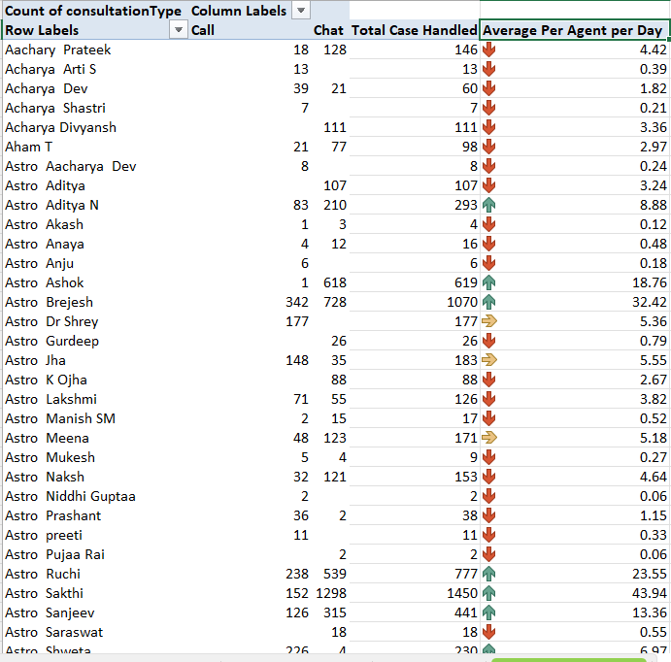

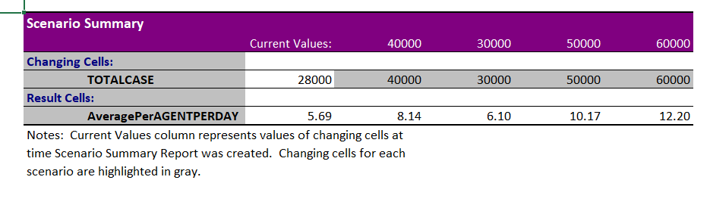

1. **What new technologies or tools could be implemented to enhance call centre operations and customer service?**

* Recommendation:-
  + **Interactive Voice Response (IVR) Systems:-**We can introduce IVR system in order to guide user properly to the GURU as per the option selection eg:- Language Selection, Problem Selection.
  + **Workforce Management Tools:-**We can optimize our work force login adherence with the WMT tool so if we manage people as per the peek and or upward trends
  + **Customer Relationship Management (CRM) Systems:-**

We can invest in good CRM systems so it will easier for the Agents to work on the assigned cases and improve overall efficiency and attend more call/chats and reduce failed/unattended calls/chats.

* + **Quality Monitoring and Training Tools:-**

A good Quality Monitoring and Training Tools will help to segregate task accordingly and will also train agent as per the system requirements.

1. **What metrics should be included in the final dashboard to provide a comprehensive view of call center performance and guide investment decisions?**

* Approach:-
  + KPIS Dashboard:-
    - As shown in the image **Revenue Generated** are the KPI’s we can include in the dashboard to get the insights from the same.
    - A Line Chart to indicate the Day by Day Volume of historical data to show call/chat trends
    - A Bar Chart to show the Distribution Over Hours.
    - A Slice to interact with the data as per year and month and consultation type.
    - A Bar Chart to show the best performing employee.
    - A Navigation bar so the user can easily navigate between the Dashboard, Raw Data and the KPI’s Section and also can reach out if having any doubt about the report.

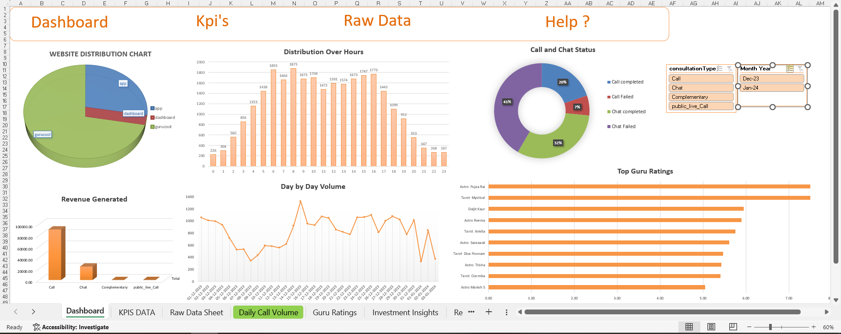

1. **How would you allocate a 1 crore rupee investment to optimize operational efficiency, enhance customer satisfaction, and boost profitability, and what analysis-based recommendations would you offer to support this?**

[you have to give bullet pointers in order to answer this question]

* **Analysis:-** (Problem Statements)
  + The Rate of Failed / Incomplete Chat is too high.

|  |  |
| --- | --- |
| **% Failed Calls** | 4.23% |
| **% Failed Chats** | 25.89% |
| **% Incomplete Calls** | 3.12% |
| **% Incomplete Chats** | 23.70% |

* + The Average Chat/Call Per Agent per Day should me more consistent between the agents but it is too volatile.



* + Satisfaction Ratings average overall is **2.93** that is the lower side and can be improved.

|  |  |
| --- | --- |
| **Guru Name** | **Average of rating** |
| Aachary Prateek | 3.11 |
| Acharya Arti S | 4.00 |
| Acharya Dev | 2.52 |
| Acharya Shastri | 3.43 |
| Acharya Divyansh | 0.39 |
| Aham T | 4.79 |
| Astro Aacharya Dev | 3.00 |
| Astro Aditya | 0.79 |
| Astro Aditya N | 3.71 |
| Astro Akash | 2.75 |
| Astro Anaya | 2.88 |
| Astro Anju | 3.33 |
| Astro Ashok | 4.17 |
| Astro Brejesh | 1.89 |
| Astro Dr Shrey | 3.56 |
| Astro Gurdeep | 2.92 |
| Astro Jha | 2.97 |
| Astro K Ojha | 0.10 |
| Astro Lakshmi | 4.13 |
| Astro Manish SM | 4.35 |
| Astro Meena | 3.66 |
| Astro Mukesh | 3.22 |
| Astro Naksh | 2.20 |
| Astro Niddhi Guptaa | 4.50 |
| Astro Prashant | 3.45 |
| Astro preeti | 3.91 |
| Astro Pujaa Rai | 7.50 |
| Astro Ruchi | 4.44 |
| Astro Sakthi | 2.54 |
| Astro Sanjeev | 2.75 |
| Astro Saraswat | 5.61 |
| Astro Shweta | 3.33 |
| Astro Sujata S | 2.90 |
| Astro Sushil S | 0.85 |
| Astro Trisha | 5.42 |
| Astro Uma Kant | 2.86 |
| Astro Vishwajeet | 2.68 |
| Astro Yashi | 2.33 |
| Astro Yogendra | 1.01 |
| Astro Aabhishek | 3.49 |
| Astro Aditya | 3.22 |
| Astro Aditya Jhha | 3.14 |
| Astro Aishwarya | 3.56 |
| Astro Anil Shukla | 1.58 |
| Astro Ankita C | 2.85 |
| Astro chandan | 1.00 |
| Astro Deepti | 3.40 |
| Astro Divya | 3.48 |
| Astro Dr Balkrisna | 4.21 |
| Astro Dr Harish | 2.81 |
| Astro Dr Ravindra | 1.85 |
| Astro Himanshu | 4.21 |
| Astro Jha Guruji | 3.87 |
| Astro Krishaa | 3.33 |
| Astro Krishna | 2.73 |
| Astro Mahesh S | 1.83 |
| Astro Manish S | 5.05 |
| Astro Neetu | 2.51 |
| Astro Nisha | 3.28 |
| Astro Pulkit S | 4.00 |
| Astro R J S | 1.45 |
| Astro Rajesh S | 1.80 |
| Astro Rajiv B | 2.58 |
| Astro Reema | 5.90 |
| Astro Rhea | 3.50 |
| Astro Rohan S | 1.50 |
| Astro Savita S | 3.69 |
| Astro SavitriDevi | 4.32 |
| Astro Seema | 3.40 |
| Astro Shalini | 3.42 |
| Astro Smarti M | 3.79 |
| Astro Sonam S | 3.72 |
| Astro sree valli | 1.63 |
| Astro Sukhdip | 4.15 |
| Astro Swami G | 4.65 |
| Daljit Kaur | 5.95 |
| Dr Balkrisna | 2.59 |
| Dr. Pratibha | 2.50 |
| Dr. Balkrisna | 3.03 |
| Dr. Harish | 1.29 |
| Dr. Shrey | 3.47 |
| Gopi Vans | 4.33 |
| gurucool support | 1.40 |
| Himanshu Pandey | 2.38 |
| Kaveshii Chauhaan | 1.95 |
| Manorma Singh | 3.24 |
| RAKESH KAUSHIK | 2.59 |
| Shalini Sharma | 4.20 |
| Super Guru Ji | 1.82 |
| Swami G | 5.00 |
| Tarot Aadhvik | 3.17 |
| Tarot Ankita | 5.75 |
| Tarot Anshu | 4.00 |
| Tarot Ari | 3.85 |
| Tarot Aritra C | 3.14 |
| Tarot Barbiie | 3.09 |
| Tarot Bibhuti | 3.67 |
| Tarot Diva Poonam | 5.46 |
| Tarot Gurpreet | 3.15 |
| Tarot Ittishri | 1.20 |
| Tarot Kaashvi | 2.94 |
| Tarot Meera | 3.87 |
| Tarot Muskaan | 2.51 |
| Tarot Mystical | 7.50 |
| Tarot Neha R | 1.89 |
| Tarot Oormika | 5.40 |
| Tarot preet | 3.00 |
| Tarot Priya S | 3.93 |
| Tarot Punam | 0.86 |
| Tarot Rupanshi | 3.63 |
| Tarot Rushali | 2.60 |
| Tarot SampritaP | 3.11 |
| Tarot Seema | 2.84 |
| Tarot Shakti | 3.48 |
| Tarot Shilpa P | 2.95 |
| Tarot Sunita | 2.86 |
| Tarot Supriya Suri | 1.45 |
| Tarot Yashita | 3.76 |
| Tarot Akshay | 2.74 |
| Tarot Bee Riya | 2.36 |
| Tarot Chanchal | 3.70 |
| Tarot Chanchal singh | 3.33 |
| Tarot Daljit | 3.51 |
| Tarot Esha | 4.12 |
| Tarot Gargi | 2.77 |
| Tarot Gauri | 3.39 |
| Tarot Gurpreet Kaur | 3.65 |
| Tarot Harleen | 3.57 |
| Tarot Keshmin | 1.24 |
| Tarot Leena | 2.07 |
| Tarot Mamta D | 3.49 |
| Tarot Monika | 4.00 |
| Tarot Nipamani | 1.72 |
| Tarot Pooja | 2.18 |
| Tarot Priyal | 4.00 |
| Tarot Rachana | 3.55 |
| Tarot Raghavi | 1.93 |
| Tarot Rhea | 4.82 |
| Tarot Ria | 2.98 |
| Tarot Rittika | 0.00 |
| Tarot Riya | 2.42 |
| Tarot Rupika | 2.85 |
| Tarot Srishti | 4.87 |
| Tarot Surbi | 3.48 |
| Tarot Swati | 1.86 |
| Tarot Vedika | 4.05 |
| Tarrot Ria | 5.00 |
| Usha Siingh | 2.15 |
| Vandana Bhutani | 4.96 |
| **Grand Total** | **2.93** |

**Recommendation:-** (Solutions)

* + To Solve the Call/Chat Failure and Incompletion we should invest in a good **CRM** and **Calling System** with **IVR**. So Agent can make a track of failed calls/chats and can manage it more efficiently and this will also make a slight improvement in the customer satisfaction rate.
  + Invest in a good **Calling system / Work Force Management system** will improve the Agent Cases per day count so this will also track the Performance of the Agent thus management can track the agent performance and KPI’s
  + A **CRM** System can also be used to provide **knowledge base articles** to the user to handle the client more effectively and improve repetitive call ration so the sales will also improve drastically.
  + Investment in a **Training System** so agents will be on track with the market and organizational trends. To handle client in more professional manner to increase sales and improve overall rating for the organization.